Requirement list:

1. Existing social media handles
2. More data on courses like these:

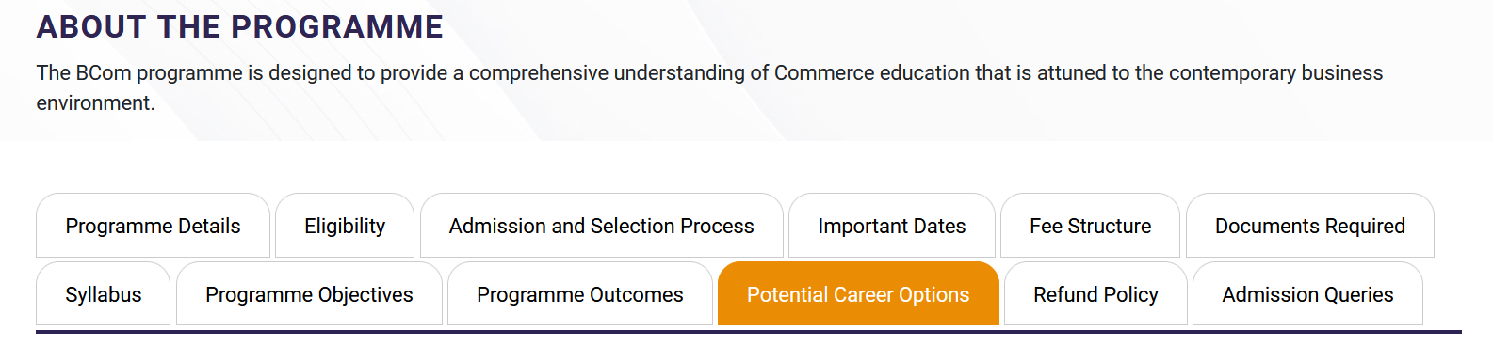

1. <https://www.sju.edu.in/> Can we use the structure of our website as reference
2. High quality logo of the college and multiple pictures of the campus to use as background
3. Does the college have handbook which we can link instead of pure text filled pages like student rules and regulations.
4. How is the admissions handled? Because the website has a form but it also asks the viewer to approach the college directly
5. How is the gallery section being handled? Is it required to have pictures from 4-5 years ago? (Attest last two years)
6. Is the admission pop up boxes required every time someone visits the site (No)
7. What is to be put in alumni, placement, career section of the website?
8. Priority list of features to be implemented based on importance.
9. Is there a backend service like linways which the college is currently using? (Pacifica)
10. Should a content management system for the staff to update data
11. Any additional requirements on top of the features present in the current website?
12. Text content for the landing page (something like this)

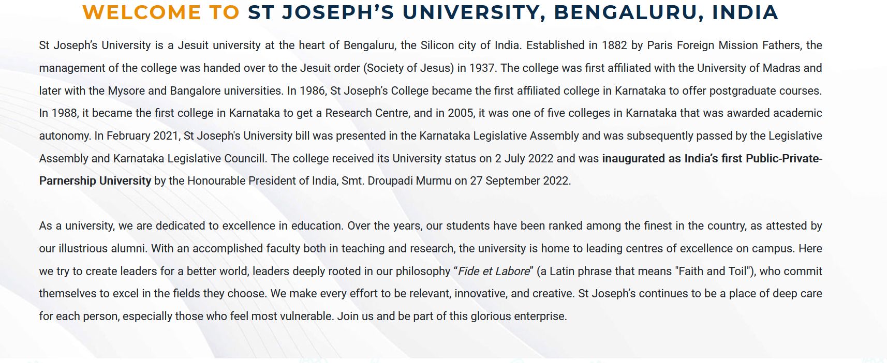

1. How frequently is the content for calendar, announcements and gallery being refreshed

**LOYOLA DEGREE COLLEGE**

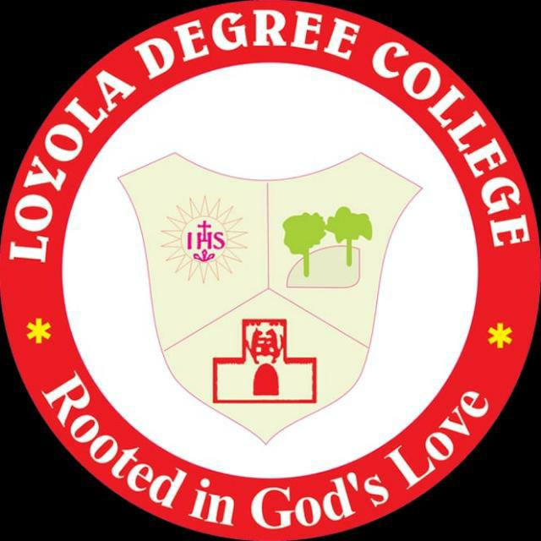

**ABOUT US**

**Founder:**

St Ignatius Loyola is the founder of the Jesuit Order that runs thousands of Educational Institutions all over the world. Born in Spain Ignatius gave up his career as a solider under the then king to become a solider of Jesus Christ and wanted to establish a world of humanity and justice. There are 16,000 Jesuits in the world today in different works for humanity with a heavy concentration in higher Education. The renowned worldwide Jesuit Universities are Loyola University Chicago, Fordham University, University of Washington in USA, Sophia University in Japan, and Loyola Universities in South America and so on.

**History:**   
In the campus of Mount St Joseph, the first educational institution was Loyola School in 1982 for the economically poor students of the neighbourhood. In 1989 Loyola Primary and Higher Primary school were established. In 1992 another institution that was added was Loyola Industrial Training Institute, where poor students are given training in fitter trade, motor mechanic, driving, electrical maintenance, carpentry etc. Hundreds of students have been given training to make a living through these trades and have excelled in society. In 2008 Loyola High School was upgraded to Loyola Composite Pre -University College. Today the Pre -University College has a strength of 600 students with Science, Commerce and Arts streams.  
  
After several years of discernments and discussions the Jesuits of Karnataka Jesuit Province finally decided to start a degree College in the name of their Founder, St Ignatius Loyola. The Loyola Degree College started functioning from the academic year 2017-18 with B. Com and BA (Journalism, Communicative English and Psychology) courses. The College is affiliated to Bangalore University. The College is a unit of BANGLORE JESUIT EDUCATIONAL SOCIETY, Jesuit Nivas, Museum Road, Bengaluru – 560025. The Campus has a spacious building, a large playground with facilities for cricket, basketball, volley ball and other sports and games.

**Management:**

**Administration:**

|  |  |  |
| --- | --- | --- |
| **Name** | **Qualification** | **Designation** |
| Rev Fr Dionysius Gerald Vas SJ | MA | Provincial & President, BJES |
| Rev Fr Brian Pereira SJ | M Sc | Vice-President, BJES |
| Rev Fr Anthony Joseph SJ | MA | Rector |
| Rev Dr Fr Alphonse Pius Fernandes SJ | MA, PhD | Principal |
| Rev Fr Denzil Lobo SJ | MSW | Finance Officer |
| Dr Vincent A | MA, MED, PhD | Vice-Principal |

**The Staff Council:**

|  |  |
| --- | --- |
| **Designation** | **Name** |
| Chairman | Rev Dr Fr Alphonse Pius Fernandes SJ |
| Finance Officer | Rev Fr Denzil Lobo SJ |
| Vice-Principal | Dr Vincent A |
| Placement Officer | Mr D. Joshua |
| Dean of Commerce | Dr Rajesh M V |
| Dean of Arts | Dr Kumaraswamy B E |
| Heads of the Departments | Ms Swetha Wenona Suvarna  Ms Rowena K  Dr Kumaraswamy B E  Dr Tara V Nair  Mr Lazarus Lepcha  Mr Vignesh G  Fr Pratap Chandru SJ |
| Staff Council Secretary | Ms Maria Thejeswini B |
| IQAC Coordinator | Ms Swetha Wenona Suvarna |
| NAAC Coordinator | Mr Vignesh G |
| Librarian | Mr K R Kumar |
| Office Superintendent | Ms Lavina Philomena Rodrigues |

**Campus Ministry:**

|  |  |
| --- | --- |
| **Designation** | **Name** |
| Coordinator | Fr Pratap Chandru SJ |
| Members | Rev Dr Alphonse Pius Fernandes SJ  Dr Vincent A  Mr Calvin George Michael  Mr D Joshua  Ms Dorita Maria Saldanha |

**Principal’s Message:**

**Vision & Mission:**

**Our Vision:** is to empower the students to be men and women for others.  
  
**Our Mission:** The educational objective of Loyola Degree College is to prepare men and women for the service of the Nation. The College provides students with plentiful opportunities to critically understand society and its structures so that education becomes a tool to work for a humane and just society. Stress is laid on academic excellence, character formation, social concern, and human development.

**College Crest & College Anthem:**

**\*Affix College Crest\***

THE COLLEGE CREST

The college crest has a rising sun that radiate the letters '”IHS" that is inscribed in the centre. This is the abbreviation of the name of Jesus (which in Greek is written as IHUS). The name symbolizes deepest faith in God, commitment to humanity and the readiness to sacrifice one's life for others. This is also the logo of the Jesuits.

On the right side is the rock which is a bed for two trees. The rock signifies the necessity of a strong philosophical foundation on which there are two trees which signify growth and development. It also signifies ecological concerns.

The bottom of the crest has the picture of the fort that belonged to the family of Ignatius of Loyola. It reminds us of the inner transformation St. Ignatius experienced in his life, after which he renounced his ambitions of knightly glory and dedicated himself to love and serve humanity and establish His kingdom of justice.

**COLLEGE ANTHEM**

March forth to a blissful life,

Onward we go with inspiration.

A serene heart to light up knowledge,

O Creator in mercy we pray.

Rooted in God's love

Let our heart's overflow:

Proclaim equality embrace unity

In our hearts let it shine

Create a world of virtues,

Spread faith in Truth and Justice.

Service we do in love forever,

Shower thy blessings

Oh! Ignatius of Loyola

Translated in 2019 from the original Kannada version by:

Dr Vincent A (Vice Principal), Ms Radhika Paraveen Castelino, Ms Sushmitha G

Music Composed in 2019 by Dr Vincent A (Vice Principal)

**Core Values:**

**Context** What needs to be known about learners (their environment, background, community, and potential) to teach them well?

Cura personalis—personal care and concern for the individual—is a hallmark of Jesuit education, and requires that teachers become as conversant as possible with the context or life experience of the learner. Since human experience, always the starting point in a Jesuit education, never occurs in a vacuum, educators must know as much as possible about the actual context within which teaching and learning take place. Teachers need to understand the world of the learner, including the ways in which family, friends, peers, and the larger society impact that world and affect the learner for better or worse.

**Experience** What is the best way to engage learners as whole persons in the teaching and learning process?

Teachers must create the conditions whereby learners gather and recollect the material of their own experience in order to distil what they understand already in terms of facts, feelings, values, insights and intuitions they bring to the subject matter at hand. Teachers later guide the learners in assimilating new information and further experience so that their knowledge will grow in completeness and truth.

**Reflection** What needs to be known about learners (their environment, background, community, and potential) to teach them well?

Teachers lay the foundations for learning how to learn by engaging students in skills and techniques of reflection. Here memory, understanding, imagination, and feelings are used to grasp the essential meaning and value of what is being studied, to discover its relationship to other facets of human knowledge and activity, and to appreciate its implications in the continuing search for truth.

**Action** How do we compel learners to move beyond knowledge to action?  
Teachers provide opportunities that will challenge the imagination and exercise the will of the learners to choose the best possible course of action from what they have learned. What they do as a result under the teacher's direction, while it may not immediately transform the world into a global community of justice, peace and love, should at least be an educational step towards that goal even if it merely leads to new experiences, further reflections and consequent actions within the subject area under consideration.

**Evaluation** How do we assess learners’ growth in mind, heart, and spirit?  
Daily quizzes, weekly or monthly tests and semester examinations are familiar instruments to assess the degree of mastery of knowledge and skills achieved. Ignatian pedagogy, however, aims at evaluation which includes but goes beyond academic mastery to the learners’ well-rounded growth as persons for others. Observant teachers will perceive indications of growth or lack of growth in class discussions and students’ generosity in response to common needs much more frequently.

**ADMISSION**

**Prospectus**

**Application**

**Online Application**

**ELIGIBILITY**

* ***BCom*** – It is mandatory that the candidate scores a minimum of 55% in the previous board examination.
* ***B.A*** – It is mandatory that the candidate scores a minimum of ____ in the previous board examination.

**GENERAL INSTRUCTIONS**

1. Application must be submitted online only.
2. The applicant should have a valid e-mail id and mobile number.
3. After submitting the application online, take a printout of the same and submit it to the college office on the same or next day. Applying online does not guarantee your seat in the college.
4. The college does not authorize any individual or organisation to process its admissions on its behalf. Candidates are advised to avoid SMS, email, WhatsApp messages and phone calls from unauthorised persons on or off its campus.
5. The registration and application fee are Rs 300, which is to be paid on the day of the submission of the hardcopy of the application and is non-refundable.
6. All admission is provisional, subject to the approval of Bangalore University.
7. The following documents to be carried along with the hard copy of the application form:
8. The photocopies of the Marks card of Class X (PUC/Class XII Marks card and Transfer certificate to be submitted, if you have received only)
9. Photocopy of Aadhar card.
10. Photocopy of Caste and Income certificate.
11. Photocopy of Migration certificate (applicable to the students of other states only)
12. Four passport size photos

**SCHOLARSHIP**

* If the candidate scores above _____% and applies within the first three days after the results, he/she is eligible for a scholarship of Rs._____.
* If the candidate scores above _____%, he/she is eligible for a scholarship of Rs. _____.

**ACADEMICS (Home page)**

**B.Com (Landing pages)**

**BA Journalism, Political Science, Psychology, Sociology, Economics**

**Study of Languages English, Kannada, Hindi, Tamil, Telugu**

**Certificate Courses Tally ERP 9, Advanced Excel, Photography**

**Question papers**

**Examination Result**

**Scholarships**

1. **B.Com (Landing page)**

B.Com or Bachelor of Commerce is an undergraduate 4- year full time degree program that provides educational expertise in the commerce stream.

**Eligibility**

Students who studied commerce as the main subject in 12th standard of schooling can opt. Also who have taken Business Studies and Accountancy in PUC or equivalent 12th std examinations are eligible to apply. The Science students with Mathematics are also eligible.

**Syllabus**

**Certificate Courses offered**

Tally ERP9, Advanced Excel

**Faculties**

1. **BA (Landing page)**

**Eligibility**

A Candidate for the BA Degree Courses shall have passed the Pre – University Examination with any combination of subjects, or equivalent is 12th standard examination of any Other Board.

Journalism, Political Science, Psychology, Sociology, Economics

**Syllabus**

**Certificate Courses offered**

Photography (Journalism Dept)

**Faculties**

1. **Study of Languages (Landing page)**

English, Kannada, Hindi, Tamil, Telugu

4. **Certificate Courses (Landing page)**

Tally ERP 9, Advanced Excel, Photography

**INFRASTRUCTURE**

**ITC Enabled Classrooms**

Studies show that the use of audio-visual aids catalyze the process of learning. At Loyola, students receive a comprehensive understanding of the world with smart-class enabled classrooms. We believe, this not only enhances the learning experience but also makes it innovative.

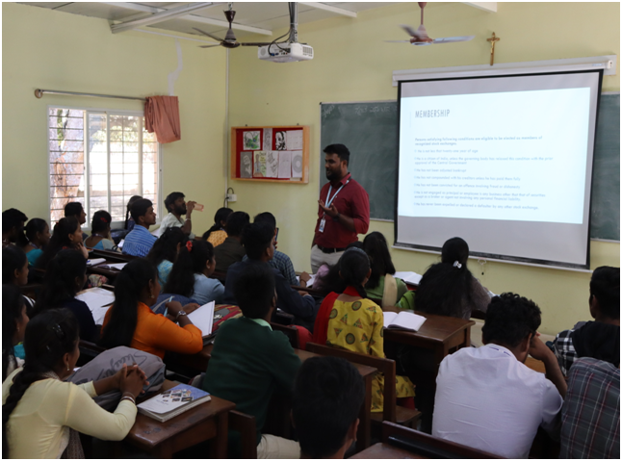

**Library**

From history to geography, philosophy to poetry, science, social science and politics, our library is a repository of immense knowledge and wisdom. Here, we encourage students to make reading a habit by providing a variety of newspapers and magazines to flick through. The library also provides previous year question bank featuring bot question papers from university as well as internal exams.

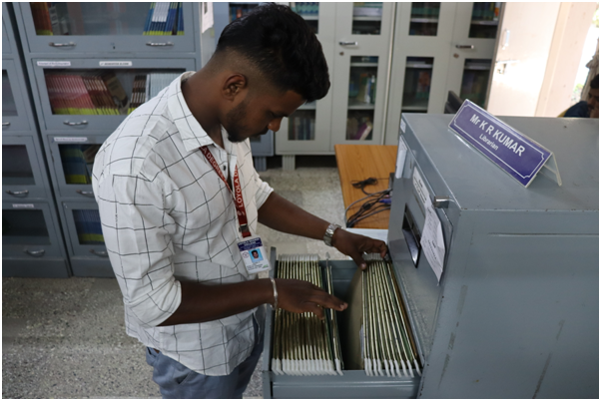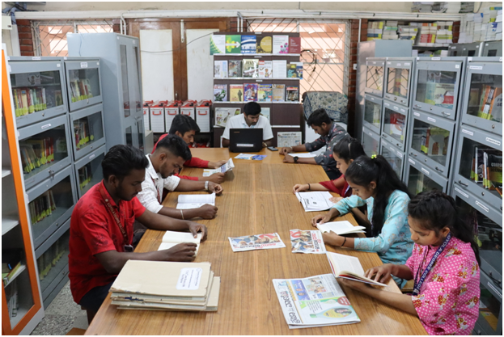

**Computer Lab**

Loyolites are provided with well-equipped computer lab for the students to engage in in- depth research related to their respective field. Internet facilities in the lab makes their study at Loyola worthwhile.

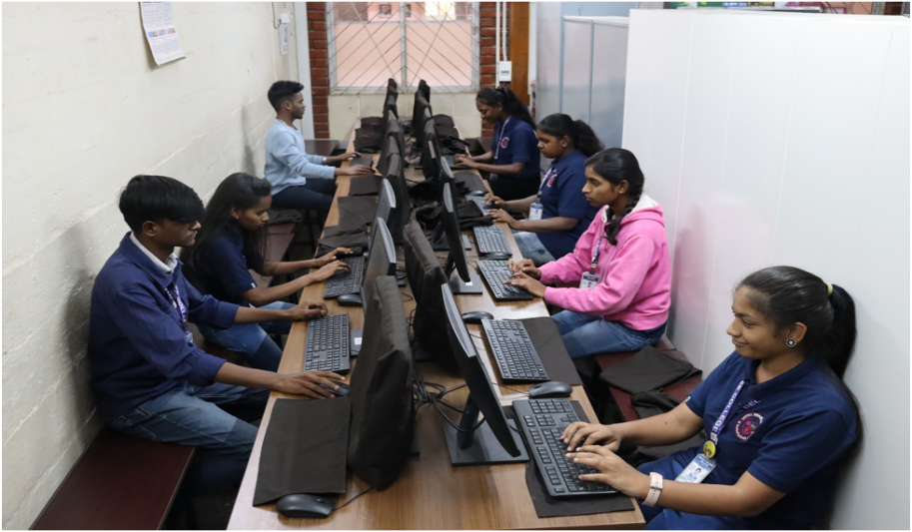

I**ndoor Games**

Indoor games such as chess, ludo and carrom provides an immersive atmosphere for the students at Loyola to engage in during their leisure.

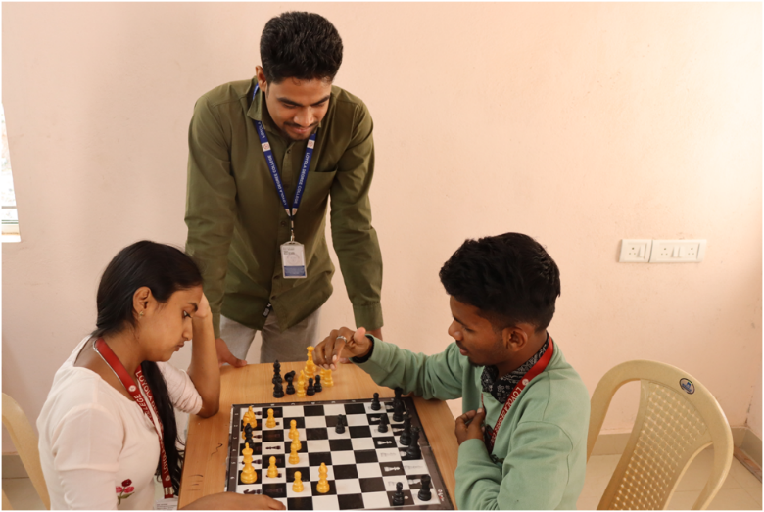

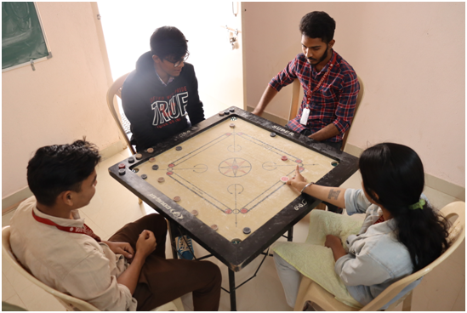

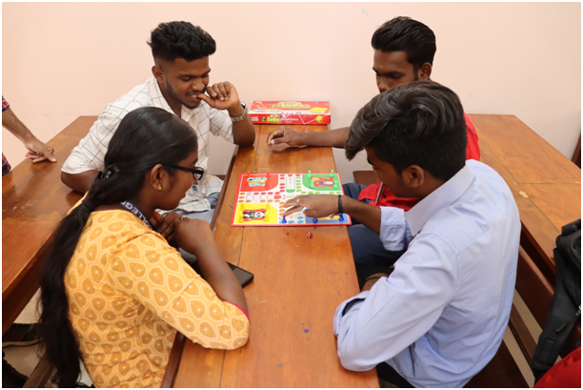

**Ground**

Surrounded by lush green trees, the vast playground is at the heart of our sprawling campus.

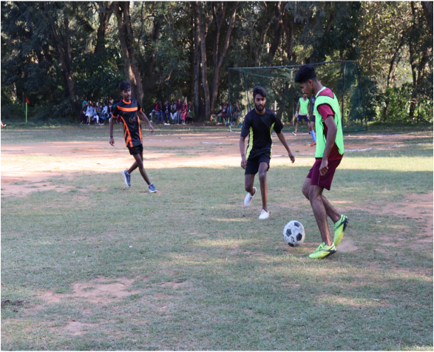 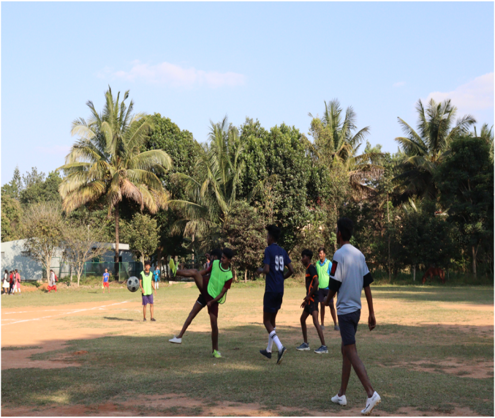

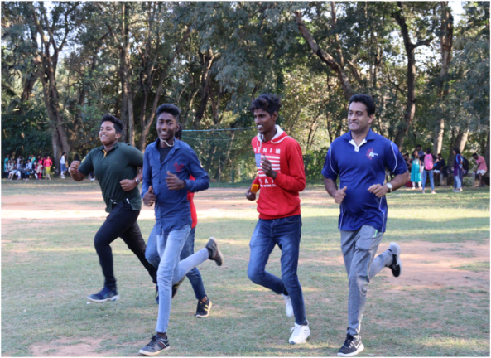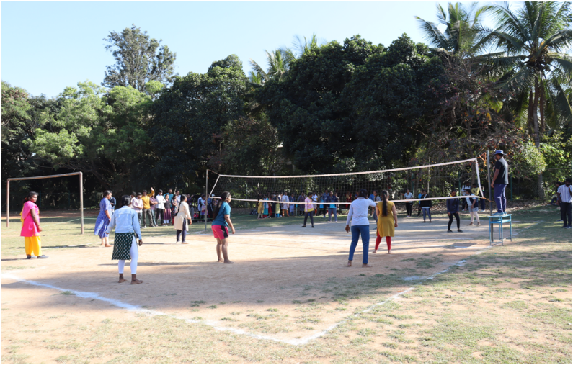

**Gym**

Students at Loyola are encouraged to do rigorous physical exercises in the well-equipped gym at our campus.

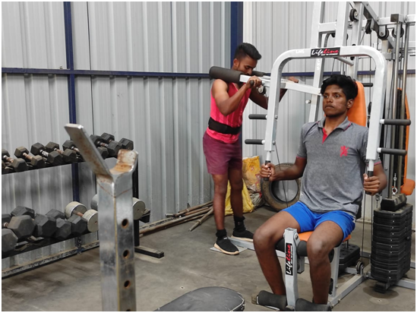

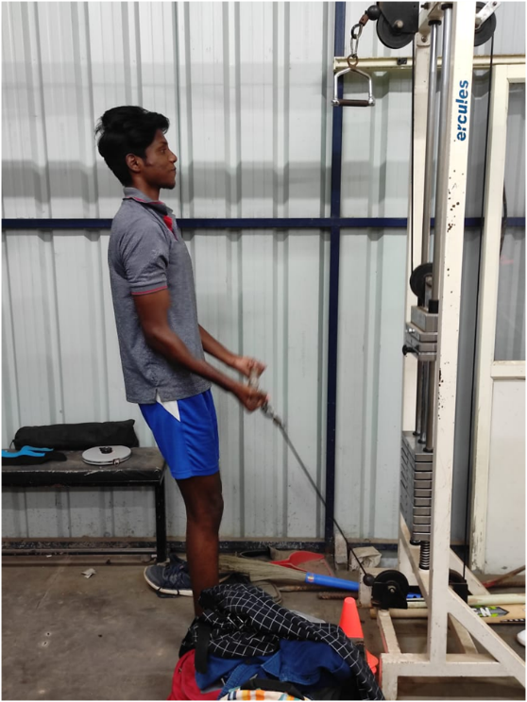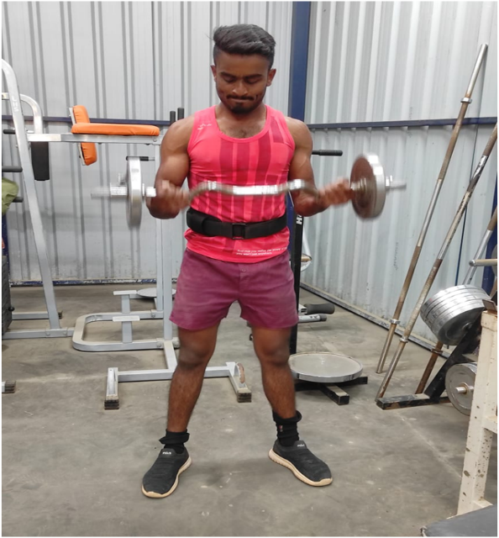

**Studio and Psychology lab**

We provide the students at Loyola with cutting-edge materials and equipment to carry out their psychology experiments. The journalism students here are trained in photography, videography and reporting at the fully equipped studio in the campus. The studio contains cameras, teleprompters and other necessary devices to make a full-fledged television/radio programme for Loy TV, a channel run by the students, for students.

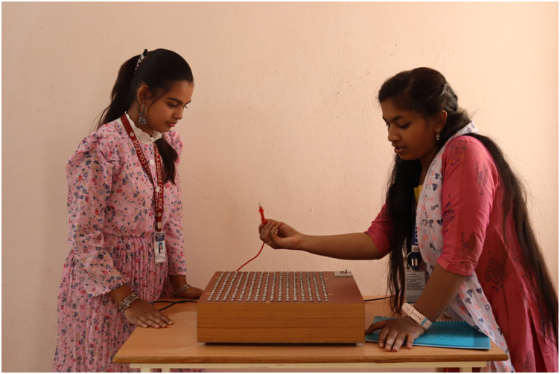

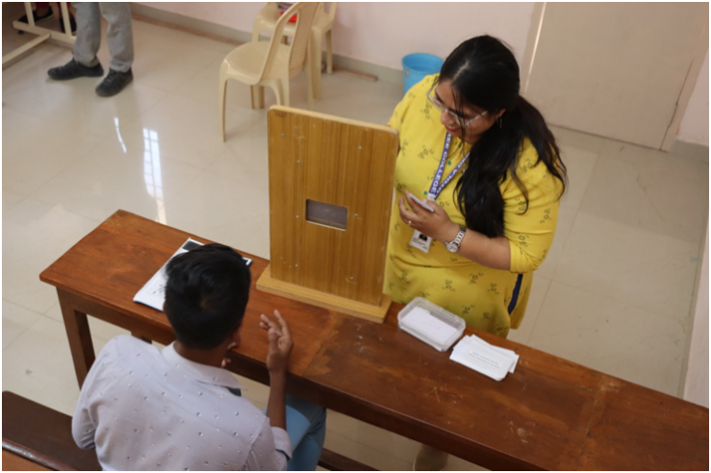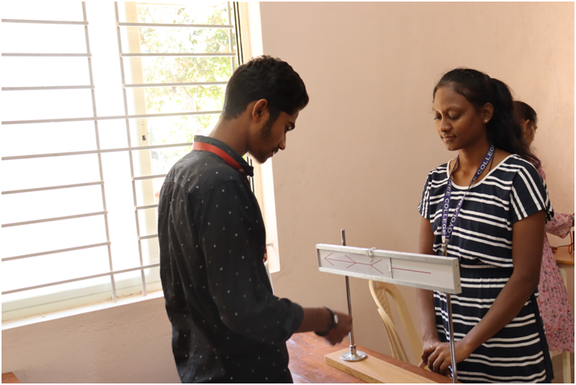

**STUDENTS CORNER**

Student Councils the world over is student-led civic organizations designed to help promote College spirit and leadership among students. Students benefit immensely from being involved in student councils – they learn leadership skills, they have an opportunity to gain experience in public speaking, they learn organizational skills and cope with challenges beyond their everyday college life, they learn how to resolve conflict amicably and diplomatically. Most of all they learn how to make a positive impact on the college and community environment.

It gives students a practical, first-hand understanding of how democracy functions by giving them a voice and a chance to contribute to the functioning of the college. A democratically elected student council allows students to practice leadership and decision-making skills as well as working hard for the benefit of their college community. Students have to think about and communicate to the electorate all the qualities that make them ideal candidates for the particular post they are interested in. The entire process right from submitting their candidature, preparing their speech, convincing the students to vote for them, getting elected, and performing their duties as responsible representatives of the student body implicitly helps students understand the true meaning of democracy.

They take responsibility for voicing the opinions and ideas of the general student body, as well as informing fellow students about current endeavors within the Student Council. In addition to planning events that contribute to college spirit, the student council is the voice of the student body. They help share student ideas, interests and concerns of the college community.

| **CLASS** | **Students Profile** | **Designation** |
| --- | --- | --- |
| **3rd B Com B** | Mr Hemanth V | President |  |
| **3rd BCom B** | Ms Sharal Acquinas | Vuice-President |  |
| **2nd B Com C** | Mr. Nikhil Teja | Secretary |  |
| **1st B Com B** | Mr. Vivek Kumar Mourya | Joint Secretary |  |
| **2nd B A** | Mr Shan Michael | Cultural Secretary |  |
| **3rd B Com A** | Mr Shreekanth R | Sport Secretary |  |

**Anti – Ragging Cell**

To root out ragging in all its forms from the institution, an anti-ragging cell has been established as per the guidelines of UGC. Ragging in any form is totally banned in the entire institution and strict action against those found guilty of ragging and/or abetting ragging is taken. All complaints pertaining to any kind of ragging by any student/group of students of the College inside or outside the College campus may be reported to ‘Anti-ragging Cell’

**Counselling**

The College provides the students with the services of professional counsellors to tackle emotional and academic problems. While the students are encouraged to visit the counsellors by voluntary appointment, the College may also refer students who may be judged to benefit from such referral. Regular value inputs are given to all students in order to deliberate on and assimilate human, social and spiritual values. Besides, a multi-religious prayer room is provided for yoga, quiet relaxation and prayer during recess hours.

**Associations**

**Why Clubs/Association @ Loyola**

Most students go to college to learn. Most know, or at least soon discover, that their academic work at college will be different than the work that they did in school. They are expected to spend more time studying and there is a higher level of thinking demanded. But the college years are also about other kinds of learning. Often much of this other learning happens outside of the classroom.

Clubs at College offers students opportunities to pursue old interests and to discover the new ones. Unfortunately, too many college students pass up some of the opportunities that they have in college, because they are too focused on either their academic life or their party life. Many worry, that getting involved in activities or organizations on campus will distract them from their academic pursuits rather than enhancing their academics.



The Commerce Association is formed to equip budding B Com students with required skill-set to be the best- fit for Corporate. It aims to develop sensible, responsible, seasoned top professionals. This club will create an inducive environment wherein our students will embrace responsibilities to serve the community and the society. Our endeavor is to sensitize future best mangers, towards privileged, challenged class. The intention of the club is to develop relationship between industry and institution in a way that students get industry exposure, and tie ups for placements and projects become easier. This club aims to provide information related to current industry activities, innovations, technological changes sharing success stories of entrepreneurs.

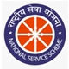 The National Service Scheme (NSS) is a Central Sector Scheme of Government of India, Ministry of Youth Affairs & Sports. It provides opportunity to the student youth of India to take part in various government led community service activities & programmes. The sole aim of the NSS is to provide hands on experience to young students in delivering community service. The focus of the club is on the personality development of the students through community service. The activities of this club cover a wide range of areas. NSS provides leadership training programmes as well as service opportunities. It effectively channels the energy and interest of the students into areas of social, cultural and community development.

 The Kannada people or Kannadigas are speakers of Kannada language and trace their ancestry to the state of Karnataka in India and its surrounding regions. Modern Kannada stands among 30 of the most widely spoken languages of the world. Kannada Sangha is established to create awareness of Kannada language and culture among the youth with Objectives to create awareness of Kannada language and culture, Make the students aware of the rich culture and literary heritage of Karnataka and make them responsible citizens of the country.

 All India Catholic University Students Federations (A.I.C.U.F) is an organization meant to impart the values of compassion and service to the student community in Universities. Our aim is to live up to the AICUF motto- “We are born into an unjust society and we are determined not to leave it as we have found it”. The AICUF unit at St. Loyola Degree College organizes various socially relevant and personality development- oriented programmes for its members. Through the outreach programmes, by which the students get practical exposure to the day-to-day living of the underprivileged and they are sensitized about the socio-economic realities of our country. Motivated by these experiences, many of the students take up the challenging tasks of contributing towards the emancipation of women and the uplift of the deprived and needy the sections of our society.



**Red Cross/ Human Rights Association**

We are reminded of the famous quote of Late Pandit Jawaharlal Nehru the former Prime Minister of India that “The youth of today is the driving force of tomorrow”. It is our duty to mould the youth to become socially useful citizens of the country.

Each generation passes on the torch of development to the next. Hence it becomes the challenge for the present generation to groom the future of tomorrow and that is the ‘Youth’. Youth Red Cross it is a group movement organized for students in colleges

**PLACEMENTS**

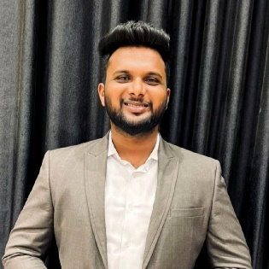

Mr. D Joshua (Mcom | Phd Pursuing)

Official Mail ID: [loyoladegreeplacement@gmail.com](mailto:loyoladegreeplacement@gmail.com)

Phone: 7760072442

**Placement at LDC - Department Profile**

The Department of Training and placement is headed by Mr. D Joshua

Placement cell of Loyola Degree College aims in equipping every student to be industry ready by offering placement training programs that are specially designed by keeping in mind the presents requirement of Job market. A series of guest lectures and career guidance sessions are conducted to broaden the perspectives of students in making them understand where they exactly fit. The placement cell provides both on campus and off campus placements assistance to the students.

**Training programs**

Along with academics the Placement cells aims in promoting employability integrated training programs for students of LDC. The Placement cell in association with TNS India foundation, Magic bus foundation and Hope foundation has organized various training programs both online and offline, the training modules covered soft skills for employability, quantitative aptitude and logical reasoning, verbal aptitude, resume building, communication, personality development, interview etiquettes, corporate linkage sessions and mock interviews.

Alongside the training curriculum to students of LDC special assistance to certificate course like Tally ERP 9 and Microsoft office – Excel. Placement Cell also helps students interested in aspiring to crack different competitive examinations such as UPSC, SSC and Bank PO.

Recent training programs conducted

* In association with TNS India foundation – Future skills program LMS – Ms. Mary
* In association with Magic bus foundation – Ms. Soumya, Ms. Prathyusha, Mr. Naveen and Mr. Chandra Mohan
* In association Hope foundation – Sis Jessy and Mr. Manjunath

**Talks & Guest lecture**

Cognitive interactions are the best way to mould student’s understanding on different topics and recent socio-economic trends, so to increase the awareness among students talks and guest lectures by eminent individuals from different walks of life is regular feature in our campus. The main aim of these series of talks is to broaden the perspectives of students in understanding all possible career opportunities they can fit themselves and choosing the right career path on completion of the studies.

**Recent activities conducted from Placement cell of LDC**

* “**NAVIGATION ‘23”** (Know where you belong) – Career guidance session for final year BCOM students was conducted on Feb 20, 2023. Specially topics such as Job opportunities after graduation, opportunities to pursue higher studies and preparation for UPSC - civil service exam was covered. The resource persons for the program were Prof Teena Maria Rani and Prof Grace Prerana from school of business, St Joseph’s University.

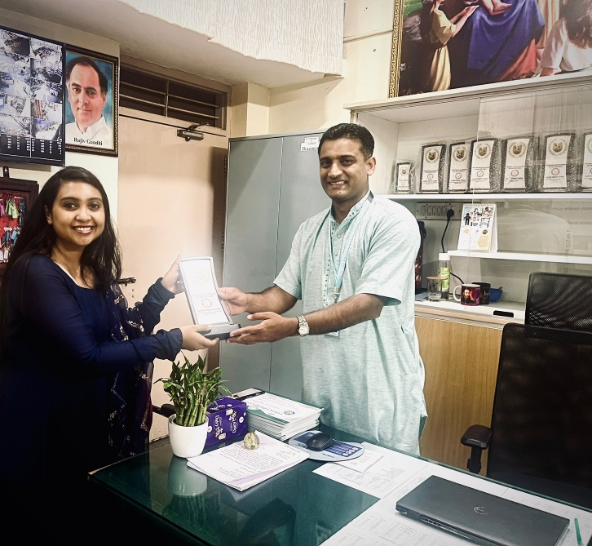 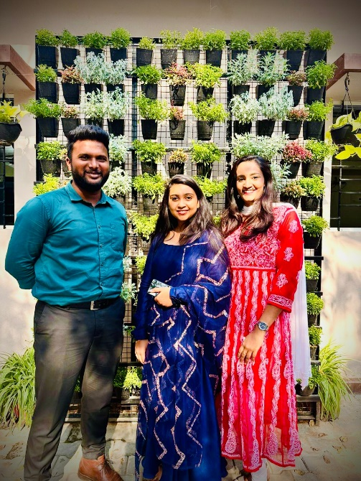

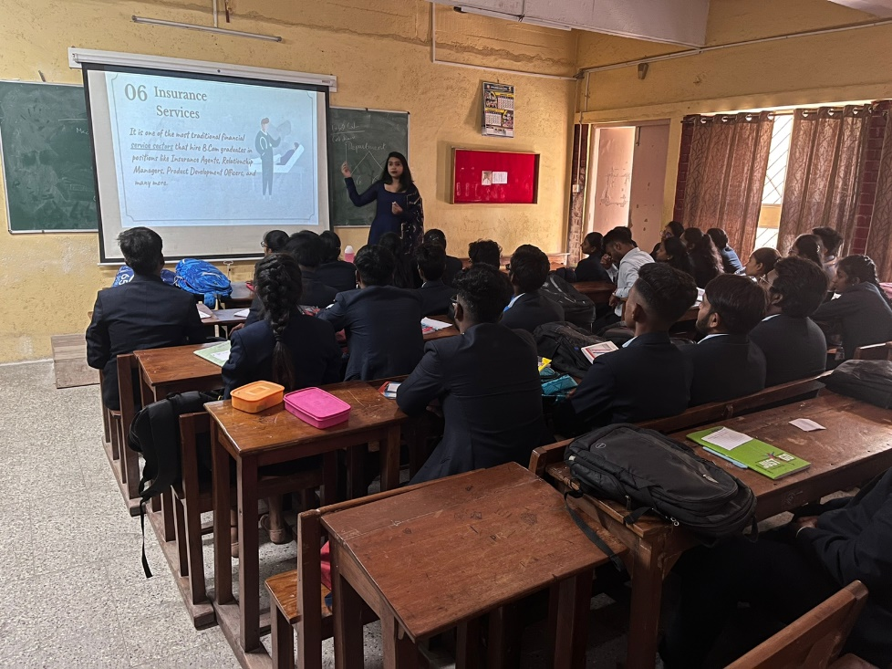

* Vijay Karnataka the largest read daily in Karnataka in association with Gillette India conducted a career guidance session for final year students of BCOM and BA on Feb 27, 2023. Special focus to opportunities in the area of communication and media covered. Mr. Sandeep the regional head was accompanied by Mr. Kishore and Ms. Chandni.

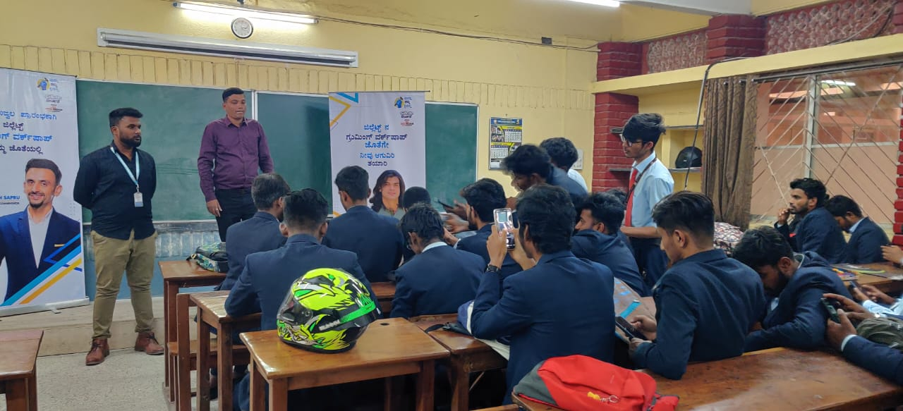

**Placement Process**

All the students of the final year batch are eligible to apply for campus placements.

Steps 1: Registering for employability integrated training program with placement cell

Step 2: Active participation and completion of assessments from the training modules with 90% results & 75% of attendance in all the placement activities will be the minimum eligibility to sit for campus placements

Step 3: Submit a copy of training certificate with name and registration number

Step 4: Release of eligibility list of students to seat for campus recruitment

**Placement statistics**

The academic year 2020 -2021 was momentous for the placement cell of the Loyola degree college. A total number of 86 students were successfully placed in esteemed companies with annual CTC of 2.5 lakhs to 3 lakhs. In the Academic year 2021 – 2022 more than 90% of the students have opted for higher studies and have admitted themselves for post-graduation in commerce and arts.

On Dec 21, 2023 campus recruitment drive was organised with L & T financial services and along with students of LDC other students from St. Joseph’s university, Christ college, AMC college and Jain University addended the job drive and were placed with 3 lakhs CTC.

Some of our esteemed recruiters are L&T, ASTER Pharma, Edutech, HDFC bank, Capgemini and Nirvana and Navi finance.

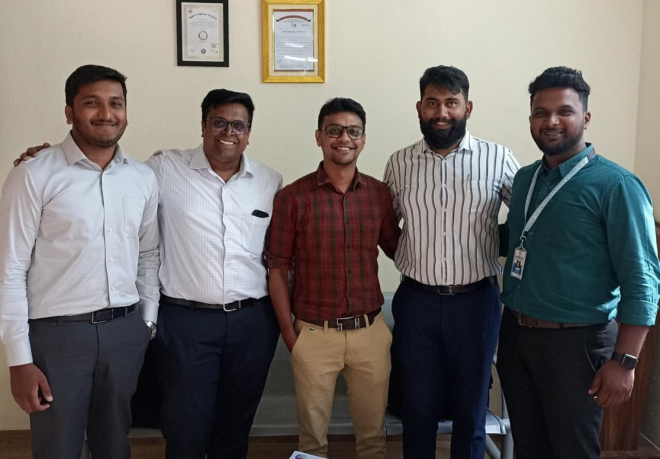

**NEWS AND EVENTS (LAST ONE YEAR’S NEWS AND EVENTS)**

**FRESHER’S DAY**

Fresher’s Day celebration for the new academic batch 2022-23 was organized on 29 th October 2022 at Gandhi Maidan. The seniors meticulously planned the event which included various games and fun activities.

The games took place in levels. The first level was Treasure hunt which was conducted on 22 nd October 2022. Six teams were qualified for the 2 nd level. Hogathon, the second qualifying event was held on 27 th October 2022. Four teams were qualified for the 3 rd round which was called Balloon in air. The two qualifying teams participated in the Fresher’s Day activities.

Diwali celebration was combined along with Fresher’s Day. The program was inaugurated by lighting the lamp while singing a devotional song. The welcome speech was delivered by Wilma of 3 rd BCom. The prayer was followed by a dance performance of the Dance Elite Group. It was an energizing and a power-packed performance.

The freshers were entertained by electric heels which led to choose ‘the best fresher.’ After the fun-filled session, the winners were awarded with exciting prizes. Lavanya was chosen as the ‘the fresher of the year.’ The program concluded with the vote of thanks proposed by Meghana of 3 rd BCom.

**FAITH FORMATION**

John 15:20 says “Remember what I told you: ‘A servant is not greater than his master.’ If they persecuted me, they will persecute you also”.

On 22 nd July 2022, a one-day retreat was organized in the Mount St. Joseph premises by the Campus Ministry of Loyola Degree College for all the Christian students of the college.

There were about 55 students who had attended this retreat along with 2 faculties. The preacher for the retreat was Rev Fr. Jerome D’Souza SJ. The retreat started with the reflection from the book of Revelation about the heavenly visions of John.

Later the preacher gave the insight about the cost of discipleship in India. He explained the current situation in which the Christians of India are living in along with the statistics. After a short break, the students were made to reflect the beauty of creation through videos and stories. It gave a wonderful thought for the students to thank the creator for his uniqueness and love for each one of his creations personally and the responsibility of the creation to discern gods will that has to be fulfilled through their lives. In the afternoon, there were penitential rites for the students, where the areas through which the distance is created between God and his people were discussed. The retreat concluded with the mass in the evening.

To increase the love of Christ in the students the college offers theology classes for the Christian students and mass is organized every 1 st Friday of the month and value education classes are arranged to all the students.

**Loyolotsava**

The Loyolotsava 2022 was inaugurated on 25 th July 2022. The chief guest for the program was Fr. Prashanth, the director of Ignatian spirituality center at Mount St. Joseph who declared Loyolotsava open. Fr. Dr. Alphonse Fernandes SJ gave the presidential address to convey the 500 th year of Ignatius conversion. Various competitions like Loyalites got talent, fashion show, instagram reels, sketching, face painting, prop making and cooking without fire were conducted. Around 300 students participated in the competitions which helped the students to explore their talents. The coordinators of AICUF Mr. Calvin and Mr. Joshua along with the AICUF members in association campus ministry took charge of making the Ignatian week a memorable one. The one-week celebration of loyolotsava was concluded by valedictory ceremony on 30 th July 2022. Fr. John Pradeep, the novice director of the Karnataka province was the chief guest for the program. The president Ms. Maziya and the vice president Mr. Shan Michael folded the flag of loyolotsava to mark the conclusion. The certificates and prizes were distributed to the winners.

**Glorium**

Loyola Degree College witnessed its third Graduation Day on 26.11.2022. Graduation Day is more than just a customary ceremony. It is a day of celebration when we laud all the hard work put in by our students and salute the efforts put in by both our students and teachers. On the Graduation Day, the energy of our graduates was unmatched as they ushered in the most awaited event of their academic life amongst their friends and lecturers in our college.

The event was presided over by the Chief Guest Dr. Cynthia Menezes Prabhu, Dean, Commerce and Management, former Vice Chancellor (In charge) Bangalore University, who graciously accepted our request to be present amongst our student community even amidst her busy schedule. The procession of the dignitaries began at around 4:45pm, a hundred and forty graduates turned up.

The President, Fr. Anthony Joseph SJ, Rector MSJ, declared the graduation day open. Dr. Fr. Alphonse Fernandes SJ, the Principal welcomed the gathering. Chief Guest Dr. Cynthia Menezes Prabhu delivered the graduation address. In her address, she told we have to be responsible citizens for our country and be grateful to our teachers for imparting knowledge.

Fr. Anthony Joseph SJ, in his presidential address mentioned to use the Jesuit values for their entire life. Graduates received their prizes and certificates. Best outgoing student was Shaun Mathew. Fr. Alphonse Fernandes SJ, the Principal administered the oath to the graduates. Graduates were asked to shift their tassels of their caps from right to left symbolizing the change of the direction of their lives. Solemn closing march kept them busy clicking pictures in their graduation attires. Gloriam’22 conceived and planned by Mr. Calvin George Michael, Convenor, was executed diligently.

**Kannada Rajyotsava**

67th Karnataka Rajyotsava was celebrated in Loyola Degree College Gandhi maidan on Saturday, 5th November 2022 with a splash of music, dance and motivating speeches by the staff and students. Program was inaugurated by Jyothi H B BBMP worker of Gottigere ward, Bangalore. Chief guest was Dr. S Balaji, State President of Kannada Janapada Parishath Bangalore. He spoke about the importance of the various folk forms in Karnataka. He stressed on the need and importance of different cultures of Karnataka through the eyes of folk styles. A group of staff members rendered Nada Geethe besides other patriotic songs, skit about BBMP workers difficulties, followed by energetic dance performances by the students depicting the culture of Karnataka. Introductory speech by Dr. Kumaraswamy Bejjihalli, the Dean of Arts. He spoke about the different problems faced in Karnataka like poverty and unemployment. The coordinators of the program were Ms. Maria and Ms. Swetha.

**ARAMBHA’22**

The fresh batch of students of 1st BCom and I BA of 2022 gathered at AULA. Mount St. Joseph auditorium for ARAMBHA’22, inauguration of the course on 29th August 2022 at 2:00pm. Dr. Vincent, Vice-Principal welcomed the gathering. An inter-religious prayer meeting conducted by Fr. Prathap Chandra SJ, campus minister, set the ball rolling. Students participated in the prayer meeting with reverence. Addressing the student community, the Principal, Dr. Fr. Alphonse Fernandes SJ spelt out his expectations on the occasion. Stressing on the four ‘C’ s of Jesuit Education, he gave a call to make use of the opportunities provided by the college. Fr. Anthony Joseph SJ, Rector, addressing the students demanded hard work and called them to be men and women for others. The programme ended with the students taking a pledge and a benediction by the Rector.

**SPANDANA (Centre for Social Concern)**

**Road safety and Traffic rules Awareness programme**

Spandana (Centre for Social Concern) in association with Hulimavu Traffic Police Station has organized “Road safety and traffic rules awareness program on 29th November. 2022 at 2:15pm. Dr. Ravikumar PG, director of Centre for Social Concern welcomed the gathering with his warm words. Ms. Spandana introduced the Chief guest Mr. Rajanna, sub inspector Hulimavu Traffic Police station to the gathering followed by Mr. Rajanna addressed the gathering and spoke about the traffic rules and regulations followed by Mr. Munniyappa, Head Constable Hulimavu Traffic police station with his thoughts on rules and regulations. Later the presidential address was given by Principal Dr. Fr. Alphonse Fernandes SJ. Mr. Hemanth V, President of Student Council thanked the gathering.

**DEPARTMENT OF COMMERCE**

**“REPORT ON INDUSTRIAL VISIT TO UNIBIC FOODS INDIA PVT. LTD BANGALORE”**

Department of Commerce organized an Industrial visit to Unibic Factory on 23rd July 2022. This visit was for the awareness of the students on the production process of the company. Fifty-five students participated in the industrial visit assisted by two faculty members. Different phases in the process of production, layouts and segment were briefly explained to the students.

The industrial visit ended on a positive note where the students were greatly benefited with the first-hand experience in manufacturing process of biscuits and cookies which provided them with practical knowledge of how an industry function.

**PARIVARTHANA**

Parivarthana 22, graduation of the first batch of students of Anveshana, a certificate course on Gandhian studies was held on September 12, 2022 at AULA, Mount St Joseph auditorium. Ms Indira Krishnappa, Secretary Gandhi Bhavan was the Chief Guest and Dr Jeevan Kumar D, former Professor of Political Science, Bangalore University was the Guest of Honour. Twenty-two students who were part of the first batch of Anveshana, on successful completion of the course marched gracefully into the venue escorted by the dignitaries. Fr Anthony Joseph SJ, Rector of MSJ and President of Parivathana 22 declared Parivarthana 22 opened.

Ms. Indira Krishnappa in her graduation address at length spoke of Gandhi and his ideals and asked the students to continue to know more and more of Gandhi and make him relevant in their life. Appreciating the format of Parivarthana, Dr Jeevan Kumar said that the certificate course would be a credit and an opportunity especially when they applying for jobs. Mr. Vignesh, the Director of Gandhian Study Centre, read the detailed report of the Anveshana 22. Parivarthana 22 culminated with a candle light procession.

**ETHNIC DAY ‘TARANG’ REPORT 2021-22**

Loyola Degree College celebrated its first Ethnic day **‘TARANG – *Embracing Differences’* on 17th August 2022**. The program was conducted by **Student Council** along with the help of **Rovers and Rangers Association** and **IQAC**.

The program started by 1:30pm at Gandhi Maidan which was blessed by the presence of Dr. Fr. Alphonse Fernandes SJ. The competitions began with the Ramp Walk for Best Ethnic Outfit (female and male). The Judges for the event were Ms. Rowena and Ms. Swetha. Sunitha from III BCOM A and Nishant Agarwalla from II BA won prizes for Best Ethnic Outfit (female and male).

The second event was a group event where each class represented a State in India. Ms. Jovita and Mr. Calvin judged the event. Ist Prize was given to II BCOM B for representing Madhya Pradesh, IInd Prize was given to II BCOM A representing Goa and a special mention was given to I BCOM C representing Karnataka. Best Ethnic Outfit Lecturers judged by Student Council members Lipsa Nayak and Hemanth G were given to Ms. Thanuja of Commerce Department and Mr. Vignesh of Department of Political Science.

Honourable Principal Dr. Fr. Alphonse Fernandes addressed the gathering appreciating the participation of the students in representing the ethnicity of different states. The program was made a success with the help of all faculties, students and Rovers and Rangers members.

**ACADEMIC ACHIEVEMENTS OF STUDENTS**

Out of 123 students who appeared for the 5th semester examination, 6 turned out to be outstanding and 33 First Class Exemplary. 102 students appeared for the 3rd semester examination, amongst whom 30 students secured First Class Distinction and 31 secured First Class.

**Outstanding Students**

|  |  |  |
| --- | --- | --- |
| BU Reg No | NAME | G P A |
| 19ITC41045 | Girivardhana T M | 9.1 |
| 19ITC41064 | Kishore T R | 9.25 |
| 19ITC41065 | Kousalya V | 9.2 |
| 19ITC41071 | Lipsa Nayak | 9 |
| 19ITC41076 | Manjunatha V | 9.18 |
| 19ITC41124 | Sharanabasava M | 9.28 |

**Christmas 2022**

Christmas was celebrated in the patio of Loyola Degree College on 23rd December 2022. The chief guest for this celebration was Dr L. Divya Darshini, B.P.T, M.I.A.P., a consultant physiotherapist. She is also a social activist at Payana TGTI (Transgender community), Bangalore. The chief guest shared her life story and experiences as a transgender with the students and advised the students about the importance of inclusiveness.

The guests of honour were Ms Rithika and Ms Kuttyma from the same community. There was a staff speech delivered by Dr Ravikumar from the Department of Kannada who highlighted the life of Jesus and His message. Students message was delivered by Ms. Shwetha of 3rd bcom A. She spoke about the preparations that are made during the season and her personal feelings about the season. Dr Fr Alphonse Fernandes SJ summarized and spoke about inclusiveness, external and internal preparations during the season. Apart from this on Christmas celebration carol singing competitions were held and the prizes were given away to the winners. Various cultural programmes were held in between the Christmas messages such as carols by winners of the carol’s competition, performance by the students of Performing Arts association and performance by the staff which were thoroughly enjoyed by the students and guests. Shan Michael (II BA), Cultural secretary welcomed the gathering. Santhosh (II BCom B) delivered the vote of thanks and Ms. Sharal Aquinus (Vice President) hosted the programme. The coordinators of the program were Ms Maria Thejeswini and Ms Rochelle in association with AICUF and Student Council.

**Student Council Elections**

On 09/11/22 the Election of the year 2022-23 for student council was conducted. Students were excited to do the voting and the election committee under the guidance of the chief election commissioner Mr. Calvin George the polling booth for the election was arranged. Every year students used to cast their votes through ballet papers but, this year new technology was used in which students casted their votes in electronic mode. The voting started at 11 am and the first votes of the election was casted by the candidates under the guidance of the presiding officer Dr. Vincent A along with the supervision of our principal Fr Dr. Alphonse Fernandes S.J. In the election polling room representatives were present on behalf of each of the candidates. The press LOY T.V headed by Mr. Lazarus Lepcha covered the entire election process and interacted the voters. At 3 pm Election was completed. The first two round results were announced in the quadrangle by our principal and vice principal it was a very exciting and thrilled movement among the voters aswell as candidates. The candidates were interviewed by LOY T V after the first-round results. Final round results were announced at 4 pm by Mr. Calvin George, the results were as follows:

1.President- Hemanth V (3RD B. Com B)

2.Vice-president-Sharal Aquinus (3RD B. Com B)

3.Secreatary- Nikhil Teja (2ND B. Com C)

4.Joint Secreatary- Vivek Kumar Mourya (1ST B. Com A)

5.Cultural Secreatary- Shan Michael (2ND B.A)

6.Sports Secreatary- Shreekanth R (3RD B. Com B)

After the announcement of the results the new council members addressed the gathering and presidential speech was given by our principal Fr Dr. Alphonse Fernandes S.J. At the end of the day the photo session of election committee members along with the new student’s council members of the year 2022-23 was held.

**NSS**

* The NSS unit, in association with Apollo Hospitals, BG Road, Bengaluru, organised an awareness session on sleep disorders in youth on March 4th, 2022 for the NSS volunteers and the cultural association students. On June 10th, 2022, a health awareness session on stress and anxiety management in association with Apollo Hospitals, Human Rights (Loyola) and Red Cross (Loyola) was organized.
* From May 7 to May 13, 2022, the Loyola Degree College NSS unit held its annual special camp at the Kanshi foundation, Kanakapura road. On May 7, 2022, the Rev. Fr. Francis D'Almeida, SJ, the former Principal, inaugurated the camp. The camp schedule included Shramaadaan and planting at Kanshi Foundation as well as on the premises of Kaggalipura Community Health Center. Eminent personalities such as Justice H.N. Nagmohan Das, Dr. Vaddagere Nagarajayya, Ms. Bhavya Narasimhamurthy, and Ms. Shahanaz addressed constitutional issues. MLA N Mahesh and Mr. Roshan Honest Raj, Placement Officer, Loyola, gave a speech on leadership and motivation. Each team presented a cultural event in the evening based on topics such as "Save Our Nation," "Mother's Day," "Clean India," "Constitution," and "Health Awareness". For the volunteers, various exercises with regards to concentration, sports, and debates were conducted.
* On June 3, 2022, at 1.40 PM, the Loyola Degree College NSS unit celebrated Environment Day by raising awareness among the students by performing a play called "Nammavaru", which was written on environmental issues and featured the various environmental elements and the ways they are being violated.
* On June 26th, international drug awareness day, Karnataka state excise department and National Service Scheme took part in a walk against drug abuse.

**STAFF ORIENTATION PROGRAMME**

The management of the college organized the staff orientation programme for all the faculties of the college on 28th May 2022 at 9.30 AM in the college. The resource person for the programme was Rev. Dr. Anil D’ Almeida SJ. The staffs were oriented on the topic Characteristics of Jesuit education, which gave a detailed insight about the responsibility of the staff towards the society. Later the group discussion was conducted where the staffs were given the opportunity to discuss in groups regarding the experience of the staff in the college with regard to service of the college towards the society, effect of NEP in the present scenario and what can be the future long and short-term goals of the institution. The programme came to an end with the presentation of above-mentioned topics.

**SPORTS DAY (LOYTRAX 2022)**

LOYTRAX 2022 was held on 11th March 2022. The program began with Guard of Honor by college president, vice president along with sports secretary. The chief guest Mr. VR Raghunath, former Indian Hockey Team captain, double Olympian, Arjuna awardee along with Fr. Anthony Joseph SJ, rector, Loyola Institutions and Fr. Francis D’ Almeida SJ, the former Principal, unfurled the college flag. Ms. Rowena was the announcer for the day. The Chief guests took the salute of the impressive March Past of the students, who were marching for different Social Causes. Dr. Vincent, Vice Principal, Loyola Degree College welcomed the esteemed guests and the gathering.

Mr. VR Raghunath shared his experience as an Olympic player and inspired students to take part in physical activities regularly. He also declared the sports meet open. The students were drawn into the spirit of the occasion with the oath taken by the Sports Secretary, Mr. Shivaji K. For the Torch parade, the Physical director Mr. Karthik K K lit the torch and passed it on to different achievers in athletics and various sports. Fr. Anthony Joseph who presided over the inaugural ceremony spoke in brief encouraging and instilling the spirit of sportsmanship. Inauguration programme came to a close with vote of thanks given by sports secretary.

Rev Fr. Joye James SJ, Vice-President, ISI, Bangalore was the chief guest for the valedictory programme. The chief guest received the guard of honor and witnessed the closing march past. Mr Kumara Swamy B J, welcomed the gathering and introduced the chief guest. The chief guest addressed the gathering and distributed the prizes for the winners of both field and track events. The overall championship was bagged by II B.com B. The Runners up were II B.com A and the III B.com A stood as the first runners.

The individual championship in men’s section was bagged by Mr, Sreekanth from II B com B whereas the championship in women’s section was a tie between Ms Renuka V H of II B com B and Delsi Meena of III B com A.

Vote of thanks was proposed by Mr. Karthik K K (Physical Director). The college flag was lowered and the chief guest declared the annual athletic meet Closed. Abide with Me marked the closing of LOYTRAX 2022.

**Workshop on The Idea of India**

The Dr. B R Ambedkar Study Centre and Gandhi Study Centre in association with Constitution Club Karnataka organized one day workshop on the Idea of India on 30th of January 2023. Mr. Sasikanth Senthil, former IAS officer was the chief guest of the programme. Ms. Najam Nazeer Chikkanerale, A social activist from Constitution Club, Karnataka, associated with us for this workshop.

The programme commenced at 9:30 am sharp with prayer service by Fr Prathap Chandru. Dr Kumarswamy Bejjihalli, director of Dr. B R Ambedkar Study Centre expressed the diversity and harmony of India through song called ***“Bharathavendre”.*** There is no country like India, quite as diverse, multi-lingual and multi-cultural, yet bound together by the ancient bounds of shared traditions, culture and values. Such bonds need to be strengthened through enhanced and continuous mutual interaction between people of varied regions and ways of life so that it encourages reciprocity and secures an enriched value system of unity amongst people of different States in a culturally special country like India.

Fr Antony Joseph SJ, Rector Mount St. Joseph and Dr Fr Alphonse Fernandes SJ, Principal Loyala Degree college led the chief guest to the flag stage. Ms. Najam Nazeer Chikkanerale, A social activist from Constitution Club, Karnataka Swetha S, HoD of Commerce department read aloud the preamble of the Indian Constitution.

Mr. Sasikanth Senthil, former IAS officer was the chief guest of the programme highlighted the rich, multicultural background of India and keenly noted that helping the needy in their hard times makes us more human. I also feel strongly that the coming days will present extremely difficult challenges to the basic fabric of our nation and that I would be better off outside the IAS to continue with my work at making life better for all."

Dr Fr Alphonse Fernandes SJ, Principal of the college spoke about the importance of choosing the right leader and said that it is the need of the hour for all the Indians to come together and combat the challenges of the current times.

The programme ended with the vote of thanks delivered by Vignesh, Director, Mahatma Gandhi Study Centre.

**Seminar on ‘Film Direction and Film Crew’**

**Department of Journalism**

The Department of Journalism in collaboration with Loy-Madhyam, organized a one-day seminar on October 29, 2021for Journalism and Loy-Madhyam students on ‘Film Direction and Film Crew’. The resource person for the seminar was Mr Seong Yoon Ryu, a Technical Director TV Studio in Sogang University, South Korea. About a hundred BA and Loy-Madhyam Association students attended the programme and along with the students of St Paul’s College, Bangalore, Don Bosco Arts and Science College, Kannur Kerala and Salesian College Sonada, Darjeeling West Bengal, joined them.

Mr Lazarus Lepcha, Asst.Professor and HOD of Journalism welcomed and introduced the resource person and the participants. The resource person highlighted the major aspects of film direction and film production. Students had a chance to clarify their doubts in the interactive session.

**MAHATMA GANDHI STUDY CENTRE**

**Mahatma Gandhi Study Centre** celebrated **Gandhi Jayanthi** on **October 2, 2021** at **9.30** am in the **College quadrangle. Dr. Jeevan Kumar,** former professor of Political Science and Director of Gandhian Studies, Bangalore University was the **Chief Guest. “Contemporary relevance of Gandhi”** was the topic of his lecture.  Students actively participated in the interaction session after the lecture. The Chief Guest appreciated the participation of the students.“ANVESHANA…..rediscover Gandhi”, a certificate course on Gandhi Studies was launched on the occasion. The Principal in his remarks motivated students to know Gandhi and live by his values of AHIMSA.The release of the book titled **“Locked and Unlocked Stories”,** compiled by **Mr. Lazarus Lepcha** was an added attraction. The NSS unit distributed the certificates for the participants of NSS camp. Dr Vincent A, welcomed the gathering and Rahul Chethri proposed the vote of thanks. Shaun Mathew anchored the programme efficiently. The programme started with the College Anthem and ended with the National Anthem.

**ENGLISH DEPARTMENT**

A webinar was conducted on July 29, 2021on the topic “***Learning in the Digital Age: Challenges in Language Acquisition***.” The resource person was Dr Kiran Prasad B. He spoke about the various challenges faced by the educational sector during this Pandemic phase. He illustrated that though digital media with its new age advancement might be considered favourable and user friendly. Nonetheless it poses a few drawbacks in learning and language acquisition.

**CHRISTMAS PROGRAM 2021**

Christmas was celebrated in the Mahatma Gandhi study centre ground of Loyola Degree College on 23rd December 2021. The chief guest for this celebration was Brother Mani Karott (LBJ), currently regional in-charge of the congregation in India. He spoke about the importance of birthdays in other religions and the message they carry in each celebration. He asked the students to take a pledge that never to allow our country to be divided by religion. The guest of honour for the day was Dr. Mudnakudu Chinnaswamy, a poet and a writer, who described the Christian Community as the people who love everyone, treat everyone equally and have actively engaged themselves in the fields of education and health taking care of all the sections of society without any discrimination. He conveyed this message with a real-life example of Sri. Chinmayananda Swamy who got influenced by the Christian missionary and started to provide service to society.  Rev. Fr. Anthony Joseph SJ, Rector MSJ of Loyola institutions in his message explained the reality of the society in the current scenario and urged students to be ambassadors of peace and harmony. Mr. Santhosh of the Department of Commerce addressed the gathering and enlightened everyone about Jesus' birth and its importance. Ms. Sunitha of 3rd BCom A. addressed the gathering representing the student fraternity. She highlighted the importance of Christmas and the preparations that are made during the season and the conditions of society at the time of birth of Jesus. Rev. Fr. Francis D’Almeida SJ delivered his presidential address in the form of a song where the students were asked to greet each other, live peacefully and in harmony. Carol singing competitions were held and the prizes were distributed. Various cultural events were held in between the Christmas messages such as carols by staff and the students, mime and dance by the students. Ms. Dorita, coordinator of the Christmas bonanza welcomed the gathering. Ms. Neethu, assistant coordinator delivered the vote of thanks and Ms. Tarika hosted the programme.

**Placement Cell**

The academic year 2020 – 21 was momentous for the placement cell of the Loyola Degree college. A total number of 86 students were successfully placed in esteemed companies and firms. ASTER Pharma, Edutech, HDFC Bank, Capgemini and NIVARA were prestigious companies that collaborated with the college and took professionally skilled candidates under its wings.

ASTER Pharma recruited students for the post of Pharmacy aide/ Senior pharmacy aide. Sixty students were shortlisted for the position in the process of the interview. The interview was conducted by Mr Sharath and Mr Pradeep, the human resource executives of the company. A total number of thirteen students were shortlisted for Edutech. HDFC bank recruited students for personal banker designation. Thirty-two students were shortlisted for the position during the interview which was held on 14 September 2021. Nivara Home Financing company recruited students from the college. The company is a fastest growing affordable housing financing company. The company recruited students for the position of management trainee, sales officer, relationship officer and field warrior. Fourteen students were shortlisted for the company. The students were drilled with ample training to taken on the interviews in pursuit of their job hunt. Career guidance was offered to the students in association with Newskarnataka.com.

Prof. Ronald Pinto, the talk-show host was involved the training the students. This training happened weekly over a period of three months. Additionally, the students were given in-house training. The final semester received training on every Friday. The students were taught to prepare resume, interview skills, soft skills, computer literacy and so on. The college collaborated with Shine Project to organise a day’s career guidance for the students. A total of 350 students participated. Mr Harsha, MD of Shine Project was the resource person for the day.

The placement cell had and fruitful and an effective year in assisting students to get into heights in securing a job. The placement cell along with helping the students to get jobs also prepared them to be prompt to face the challenges of the world outside.

**Psychology Webinar- Detailed Report**

"Addressing Abuse during Lockdown”

Loyola Degree college had organized a Webinar on 30.07.2021 on the topic "Addressing Abuse during Lockdown. The Resource Person was Ms. Arpitha Anand, RCI Licensed Clinical Psychologist. Ms. Arpitha spoke about the different types of abuse which included physical, sexual, emotional psychological, verbal, financial, cultural and spiritual. She laid emphasis on child abuse and presented it with statistical data. Different Types of child abuse, Signs of abuse, Myths around abuse and Truths of Child Sexual Abuse was discussed. Ms. Arpitha discussed about Awareness regarding any kind of abuse and its importance in the society. Intimate Partner Violence and Domestic Violence were the other issues discussed during the webinar. The different expressions of Emotional abuse were explained which included seven abuse terms such as Love bombing, Gaslighting, Stonewalling, Triangulation, Devaluation, Projection and Cutting your Lifeline.

**Rotract Club**

The inauguration of Rotract Club happened swiftly in the college premises. The Principal, Fr Francis D’Almeida SJ, Dr. Tara Nair, the co-ordinator of Rotaract Club, along with the student body welcomed the Chief Guest and the Dignitaries of the event. Dr.V. Tara Nair welcomed the gathering. The meeting took off with a prayer song. The Principal, Fr Francis D’ Almeida SJ inaugurated Rotract club in the college. The program was graced by the presence of the Chief Guest, Mr. Ramachandaraiah. R, the director of youth service, Mr.Amarchetan, the mentor of the youth services and the president of rotaract club, JP nagar Rotarian,Mr. Kumarswamy & the Assistant Governor Rotarian Mr. Girish Arabhaya. Other programmes included, collaring the current President of the Rotaract Club. Badges were officially offered to all the newly appointed members of the Club. Furthermore, the acceptance speech was delivered by Nishant Aggarwal.

Lastly, the vote of thanks was executed and the meeting was adjourned by the President of the Rotaract.

**SPORTS**

Various inter class matches were held to enhance their social interaction and test one’s physical ability. These competitions gave a break to the students from their routine work and energised them. The following were the matches which were held at the campus

|  |  |  |  |  |
| --- | --- | --- | --- | --- |
| **SPORTS** | **DATE** | **SEMI-FINALS** | **FINALS** | **WINNERS** |
| Football (Men) | 21/10/2021 | * III B.com ‘B’ v/s I B.com ‘A’ * B. A v/s II B. Com ‘B’ | B.A v/s I B.com ‘A’ | B. A |
| Throwball (Women) | 3/11/2021 | * II B.com ‘B’ v/s III B.com ‘A’ * B. A V/S II B. Com ‘B’ | III B.com ‘A’ v/s II B.com ‘A’ | III B.com ‘A’ |
| Kabaddi  (Men) | 16/11/2021 | * I B.com ‘C’ v/s I B.com ‘A’ * II B.COM ‘B’ v/s III B. Com ‘A’ | II B.com ‘B’ v/s I B.com ‘A’ | II B.com ‘B’ |
| Kabaddi  (Women) | 16/11/2021 | * II B.com ‘B’ v/s III B.com ‘B’ * I B.COM’C’ v/s II B. Com ‘A’ | II B.com ‘A’ v/s II B.com ‘B’ | II B.com ‘A’ |

**St. Joseph College, Hassan Football tournament**

On December 3, 2021, eight Loyola Degree College students had been to St. Joseph's College in Hassan for a football tournament, where the team lost in the quarterfinals.

**Inter Collegiate Athletics meet**

Fifteen boys and seven girls from Loyola Degree College took part in the 56th Inter-Collegiate Athletics Meet held at SAI, Bangalore from December 16 to18, 2021. Srikanth, a student from II B.com 'B' secured the bronze in Long jump.

**State Level kabaddi participation**

Mr. Shivaji K of III B.com ‘B’ was selected for the state-level kabaddi championship, which was held in Shivamogga at Amateur Kabaddi Sports Federation of India from 12 to 14 November 2021.

**Inter college Kabaddi tournament**

Inter college kabaddi private tournament was held at BES college Jayanagar on 30 December 2021. The college team reached until to the quarter finals and 10 students from our college participated in this event.

**BA Media Visit.**

Media visit adds an experience in one’s learning of Journalism and the curriculum of the university highly recommends it. The university has made it mandatory to have the media tour. A one-day tour to Vijaya Karnataka (TOI), and Praja Satya, newspaper industries in Mysore on September 9, 2021. Students were taken to various desks of the printing press and were introducing the functioning of the newspaper press. Students had an opportunity to ask and clarify various queries related to printing press and newspapers. The visitation of Vijaya Karnataka was followed by the visit to Praja Satya newspaper, a small-scale newspaper industry wherein students had an ample opportunity to know more about newspaper and photography.

**STUDENTS ACHIEVEMENTS**

* **Shan Michael** participated in various district and state events and competitions, winning prestigious recognitions. He has secured 2nd place in vernacular singing held at Mount Carmel college, 1st place in state level poetry writing and presentation, 1st in state level Bhavageethe competition, chosen as ‘Master of the ceremony' for Vishwa Kannada Sahithya Parishad 2021, Awarded as ‘Karnataka’s young poet’, and nominated for ‘Kittur Rani Chanammasahithi’award, Karnataka Literature Star Award and many more.

* Mr. Rahul Chettri of Loyola Degree College, Bangalore, won the 1st prize in **Dr APJ Abdul Kalam International Level Essay Writing** Contest, Season-5. The essay competition was based on the theme, “Category 2 Covid 19 and Remote Learning: Is this a Change for Good”. The contest was conducted by IFIM COLLEGE (AUTONOMOUS) Bangalore in collaboration with NAAC & E-LEAD.

* The world record of “MOST FULL EXTENSION PUNCHES ON DUMMY IN A MINUTE” is achieved by MR. Arvind N S(III B.A) on 18th  November 2020. He did 340 full extension punches on  dummy in a minute and has set a new world record for international book of records.
* Kusuma S III - BA, Rahul Chettri II - BA, BinouyD’costa, Shan Michael, and Sana Fathima I – BA, bagged the second place for their heart-wrenching documentary ‘Trans Strains’ which focused the life of transgender community Bangalore during pandemic. The documentary is directed by Sana.

Nishant Agarwal, Hemanth G of II-BA, Priyanka of I-BA, and Rukshar of I-B.Com A, fetched the third prize for their motivating documentary on Police, directed by Nishant. The winners were awarded with cash prize and e-certificates on the valedictory. The screening of the documentary will take place on Human Rights Day, December 10, 2021 at St Joseph’s Law College, Bangalore.

**STAFF ACHIEVEMENTS**

* **Mr. Ravikumar P G** was invited as a resource person in a webinar titled, “Sharanaru:  panchaachaara – sapthachaaraparikalpane”, organized by siddha mangala seva kendra on August 25, 2021.  He was also a recipient of “Kayakayogiprashasthi” by the same Kendra and the award was given on August 7, 2021.
* Ms Swetha Wenona Suvarna from the Department of Commerce cleared the KSET in the month January 2021.

**HUMAN RIGHTS**

Red Cross and Human Rights jointly organized Human Rights Day. Human Rights Day celebrations kicked off at 2:30 pm on December 10, 2021 in Patio. There was active participation from all students.

Human rights day was celebrated by holding various student competitions, including painting competitions, college competitions, pick and speak and essay competitions.

**RESULTS**

**OVERALL PERCENTAGE**

|  |  |  |  |  |
| --- | --- | --- | --- | --- |
| **Year** | **Semester** | **Total Attended** | **Pass** | **Results %** |
| 2019-2022 | 3rd | 127 | 114 | 90% |
| 2018-2021 | 5th | 129 | 117 | 91% |

**Constitution Day Report**

On November 26, 2021, Loyola Degree College celebrated Constitution Day at the Mahatma Gandhi Study Centre Maidhan at 11AM. Dr Dayanad Naik, Associate Professor of Political Science department from Mangalore University was the guest of honour. The guest of the day spoke at length on the importance of the constitution and its relevance toady. The programme was presided over by Fr Anthony Joseph SJ, Rector Mount St Joseph. In the absence of the Principal Dr Vincent A, the vice Principal delivered the introductory remarks and welcomed the gathering too. The introductory talk as well was highly motivated which was on the preamble of the constitution.

After the formal programme on the occasion the college conducted various competitions to promote awareness on the Constitution of India. The competitions were,

1. Essay Writing on Indian Constitution
2. Speech on Indian Constitution
3. Collage Making on four themes,
4. Liberty
5. Equality
6. Justice
7. Fraternity

More than 200 students participated in all the competitions and exposed their skills and knowledge on the Constitution of India.

**REPORT ON FAREWELL FOR THE BATCH OF 2018-2021**

“Not the End only a different beginning…”

In an emotionally surcharged atmosphere in the college patio, the students, staff and management of the College bid adieu to the final year students of 2018-2021 batch, at a grand farewell function held here at the College campus on September 15th 2021 at 2.30pm.

The program began with the prayer followed by MC taken over by Mr Shaun Mathew of II BA.

There were cultural programmes by the juniors and staff. The final years reciprocated by coming on stage for one last time with their dance performance. One representative from each class of III B com and BA shared their experiences and memories in the college. Fun games were conducted as fillers between the program which was co-ordinated by Ms Swetha and Ms Maria. Dr. Vincent raised the toast wishing prosperity and success to the students who would be going out to the world with a new role in life. The programme was ended with DJ.

**REPORT ON STUDENT COUNCIL ELECTION 2021-2022**

**“A leader is one who knows the way, goes the way, and shows the way”.**

The election for the “Student Council” for the year 2021-2022 was held on 16th October 2021, Saturday in the college premises. on 24th June, 2021. On the day of the event for the post of president 5 students, for the post of secretary 4 students, for the post of cultural secretary 3 students, for the post of joint secretary 9 students were nominated. As there was only one candidate for the position of Sports secretary, Mr Shivaji from III B COM 'B' was unanimously chosen. At 10.30 AM, the students finished voting. At 10.45 AM counting began.

At 12 PM the result of the student council election was ready and it was announced by the principal along with the student Council Director Ms Maria Thejeswini B.

The glorious winners elected by the students are as follows

|  |  |  |  |
| --- | --- | --- | --- |
| **Sl No** | **Designation** | **Name of the Student** | **Class and Section** |
| 1. | President | Chris Harish | III B COM A |
| 2. | Vice - President | Divya Darshini | III B COM B |
| 3. | Secretary | Hemanth V | II B COM B |
| 4. | Joint Secretary | Chandana P | I B COM B |
| 5. | Sports Secretary | Shivaji K | III B COM B |
| 6. | Cultural Secretary | Hemanth G | II BA |
| 7. | Academic Secretary | Lipsa Nayak | III B COM A |

In conclusion, our principal thanked each candidate who participated in the election, and as always, he encouraged us with encouraging words.

**REPORT ON STUDENT COUNCIL INVESTITURE 2021-2022**

The Investiture Ceremony for the academic year 2021-2022 was held on the 22nd October 2021 at 2.30 pm. The chief guest for the event was Dr.Jerome Xavier - Principal, St. Vincent Pallotti College, Chellekere.

The ceremony began with College Anthem and prayer, co- ordinated by Ms Swetha and Mr Lazarus along with choir team of the college. A welcome speech given by newly appointed student council director Ms Maria Thejeswini B followed by lighting of the lamp by the chief guest, principal, vice – principal, director of student council, president and vice president of the college. The student council files were handed over by the ex- student council director Mr Ravi Kumar to the present student council director Ms Maria Thejeswini B.

The badges were presented by the chief guests to the student council members along with class representatives and sports representatives of each class. The college flag was handed over by the principal to the president of the college which signifies to take responsibilities and to serve the college faithfully. The Oath taking ceremony was led by Mr Chris Harish of III B COM A for the office bearers.

In his address, the Chief Guest Dr Jerome Xavier appreciated the efforts by the college for providing opportunities to the students to take part in activities like these. He also congratulated the newly appointed student council members for their preparedness to take responsibilities. He asked them to use these opportunities and balance them well with academics to excel in both. He wished well to all the members of the student council. He commended the college for having thought of an Innovation to do away with the posts of the president and vice president to provide an equal opportunity to all the students in administration and decision making.

The principal wished the student leaders in completing responsibilities entrusted to them in the year ahead. He also mentioned the efforts taken by the college in promoting student’s democratic and social skills and offered his support in the future. His words of advice were highly motivating to the students.

Mr Chris Harish – President of the college rendered his speech by addressing the gathering and shared his gratitude to the management and faculties of the college.

The prestigious programme was ended with vote of thanks by the Vice president – Ms Divya Darshini of III BCOM B and Master of ceremony Ms Rowena.

**Leadership Orientation workshop**

The principal announced that there will be an Orientation work shop at Ashirvad, #30, St. Marks Road, Bangalore. Accordingly, Mrs Maria Thejeswini, the Director of student council made all arrangements. All council members enthusiastically participated in this workshop. The workshop happened for three days . Various sessions on team work and co-ordination were organised for students to instal leadership qualities among students by qualified resource person. To increase the zeal for students various games were conducted .

|  |  |
| --- | --- |
| Resource person | Topics |
| Fr Francis D almeida | Leadership skills and Leadership Styles |
| Mr Roshan Honest Raj | Team building/ Team work |
| Mr Karthik | Leadership Discipline |
| Fr Joyson Vas | Peer pressure |
| Mr Raajath | Psychological aspects |
| Mr Lazarus | Communication Skills |
| Ms Maria Thejeswini B | Community Service |
| Fr Brain Pereira | Decision making skills |
| Ms. Sameera Fernandez | Goal setting |
| Br Suman S J | Prayer and Yoga session |

**REPORT ON FRESHER’S DAY 2021-2022**

On 13th November 2021 freshers day was organised for freshers in ITI hall. The main purpose of this fresher’s day was to welcome the new Loyolites and to guide them in excellence of learning new things. The cultural association members and student council members organised various cultural programs for the freshers. They also conducted games for both freshers and the new teachers who joined the Loyola family.

Lastly Mr and Ms Loyolite were chosen by conducting various competitions.

Mr Nathaniel Clifford from 1st BA as Mr Loyolite and Ms Tharika from 1st B.com 'A' as Ms Loyolite.

**Digital Fluency**

**A report to the Newsletter**

The new education policy has been adopted by the government of Karnataka at the undergraduate level of Education. There have been major changes in the system of education with the introduction of New Education Policy. Digital Fluency is a subject that has been introduced for the undergraduate programme across the entire state of Karnataka.

Digital Fluency aims at providing computer literacy. The knowledge of computers makes the students ready for the challenging world and provides them avenue to grab the opportunities that come their way. Living in the millennial era arise a need to be computer and tech-savvy. The working knowledge of the computers will provide students with an upper hand in penetrating to the industry.

The Subject deals with the basics of computer. The rudiment of Computer is the primal focus of the subject. The students are initiated and given a detailed exposure of computers. They are also introduced to the universe of the internet. The are acquainted with receiving and sending of mails. They are given access to the world of computer and internet which helps in employability.

This novel introduction to the syllabus by the university in keeping with the New Education Policy is commendable. But the ambiguity in terms of the execution of the subject is alarming. The Guidelines for Teaching and assessment by the university should be provided. The clarity of the methodology and evaluation would greatly benefit the teaching and the student fraternity. Digital Fluency is a boon to the students at the undergraduate level.

**LIBRARY**

Loyola Degree college library is a new library and 5 years old. It regularly subscribes to five national journals and three international journals, periodical/magazines and eight daily newspapers. It caters to the needs of more than 510 graduate students and 30 staff.

The library follows the Dewey Decimal Scheme of Classification. Books are arranged on the shelves, Author wise, Semester wise and Subject wise. The Library is open from 8.30 a.m. to 4.00 p.m.

The library can accommodate over 25 students at a time. Additional services provided by the library are as follows:

1. Internet and Wi-Fi service

2. E-newspaper service

3. Reprographic service

4. SC/ST Book Bank Service

5. Lending service and

6. Old question papers service

Over the years the college library has a collection of large number of books and the statistics is tabulated below for reference.

|  |  |
| --- | --- |
| **NAME OF THE RESOURCE** | **NUMBERS** |
| No. of Books in Total | 5,420 |
| Total No. of Reference Books | 589 |
| SC/ST Book Bank | 574 |
| Competitive Books | 24 |
| Donated Books | 1,617 |
| No. of National Journals | 5 |
| No. of International Journals | 3 |
| Magazines | 8 |
| News Papers | 8 |

|  |  |  |
| --- | --- | --- |
| **Contributions from July 2021 to December 2021** | | |
| Mr Santhosh Kumar, Kadri | Rs. 3000 | NSS Fence |
| Fr Hilario | Rs. 38250 | Scholarship |
| Jasmine Angel | Rs. 5000 | Scholarship |
| Suthar | Rs. 10000 | NSS Fence |
| Eastern Associates | Rs. 5000 | NSS Fence |
| Suchitha Anchan | Rs. 25000 | NSS Fence |
| Terence Marian D'Souza | Rs. 5000 | NSS Fence |
| Maryan | Rs. 4000 | Scholarship |
| Renuka | Rs. 3000 | Scholarship |
| Alexis | Rs. 10000 | Scholarship |
| Naveen | Rs. 9000 | Scholarship |
| Philip Andrew Mascarenhas | Rs. 3000 | Scholarship |
| Rahul Advertisers | Rs. 4000 | Scholarship |
| Mathew Moras | Rs. 4000 | Scholarship |
| Harish Shenoy | Rs. 3000 | Scholarship |
| Allan | Rs. 5000 | Scholarship |
| Koshy Nagaland | Rs. 5000 | Scholarship |
| C Indu | Rs. 5000 | Scholarship |
| Sebastian | Rs. 10000 | Scholarship |
| Xavier Board of Higher Education | Rs. 10000 | Scholarship |
| D’Souza | Rs. 10000 | Scholarship |
| Zelia | Rs. 5000 | Scholarship |
| Richard | Rs. 10000 | Scholarship |
| IIS | Rs. 6500 | Sublaltern |